**CSD 1133 – 2021S**

**Student ID: 901142  
Student Name: Roshan Shrestha  
Assignment #2 ---------------------------------------------------------------------------------------------------------**

Design a **Flowchart and Pseudocode** for the following Problem Late Assignments will not be accepted or marked!

**Tip, Tax, and Total:**

Design a program that calculates the total amount of a meal purchased at a restaurant. The program should ask the user to enter the charge for the food, and then calculate the amount of a 15 percent tip and 7 percent sales tax. Display each of these amounts and the total.

**Pseudocode:**

// Declare global constant for tip and sales tax rate

Constant Real tip_rate = 0.15

Constant Real sales_tax_rate = 0.07

// Main module

Module main()

// Declare local variables for charge amount, tip amount, sales tax amount and total amount

Declare Real charge_amount

Declare Real tip_amount

Declare Real sales_tax_amount

// Get the charge amount

Call getChargeAmountModule(charge_amount)

// Calculate the tip amount

Call calculateTipModule(charge_amount, tip_amount)

// Calculate the sales tax amount

Call calculateSalesTaxModule(charge_amount, sales_tax_amount)

// Calculate and display total amount

Call calculateDisplayTotal(charge_amount, tip_amount, sales_tax_amount)

End Module

// The getChargeAmountModule asks user input for charge amount for the food and stores in

// the reference variable charge_amount

Module getChargeAmountModule(Real Ref charge_amount)

Display "Enter the charge amount for food: "

Input charge_amount

End Module

// The calculateTipModule calculates tip amount and store the value in reference variable

// tip_amount

Module calculateTipModule(Real charge_amount, Real Ref tip_amount)

Set tip_amount = charge_amount * tip_rate

End Module

// The calculateSalesTaxModule calculates the sales tax amount and stores the value in reference variable sales_tax_amount

Module calculateSalesTaxModule(Real charge_amount, Real Ref sales_tax_amount )

Set sales_tax_amount = charge_amount * sales_tax_rate

End Module

// The calculateDisplayTotal calculates and display the total amount along with charge amount, tip amount and sales tax amount

Module calculateDisplayTotal(Real charge_amount, Real tip_amount, Real sales_tax_amount)

Declare Real total_amount

Set total_amount = charge_amount + tip_amount + sales_tax_amount

Display "The charge amount for food is: " + charge_amount

Display "The tip amount for food is: " + tip_amount

Display "The sales tax amount for food is: " + sales_tax_amount

Display "The total amount for food is: " + total_amount

End Module

**Flowchart:**

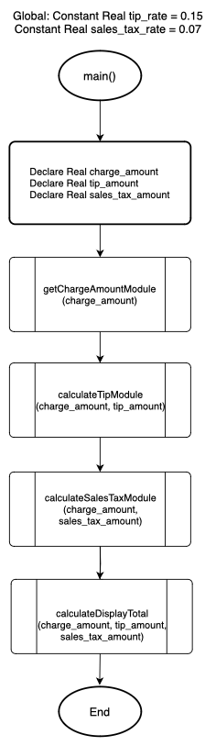

Figure 1: Main module

Figure 3: Tip calculation module

Figure 2: Get charge amount module.

Figure 5: Total calculation and display all values module.

Figure 4: Sales Tax calculation module